**AIT-524, Class 01, Practice Problem**

**TEAM MEMBER:**

Ibifubara Iganibo, Mochammad Saputra, Spencer Woodfork, Tanmoy Chowdhury,

**Practice Problem 1:**

**Introduce Yourself:**

I am Tanmoy, doing PhD in IST department.

**Practice Problem 2:**

**What is data?**

* Can be any object or entity that can later be processed into useful information.

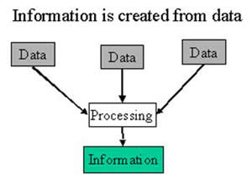

**What is a database?**

* An organized set of stored information usually on one topic.
* A collection of records
* A location where one can Insert, update, delete, and sort information.

**What are the main types of databases used for organizations today?**

* Relational database: For most government or older projects
* Non-relational databases: For most commercial/social network based/ modern and newer projects.
* Object Oriented Database:

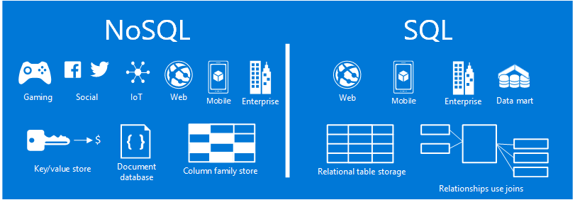

**Practice Problem 3:**

**What is a relational database?**

* Is a structured database that requires a Schema?
* Can recognize relations among stored items.
* Based off of a relational model which includes entities.

**What is NoSQL**

* Does not require a Schema.
* Stores data in columns rather than rows (as done in relational databases).
* No Tabular relations

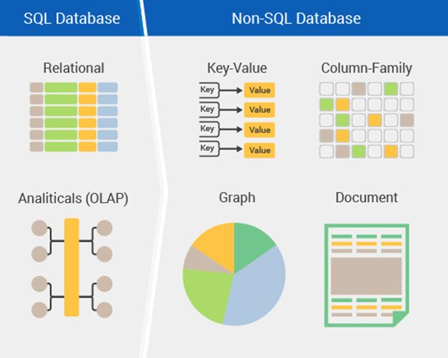

**Why different types of databases exist?**

Because each type of database is more useful for specific situations / projects/ applications.

Based on the demand and criteria given by the customer.

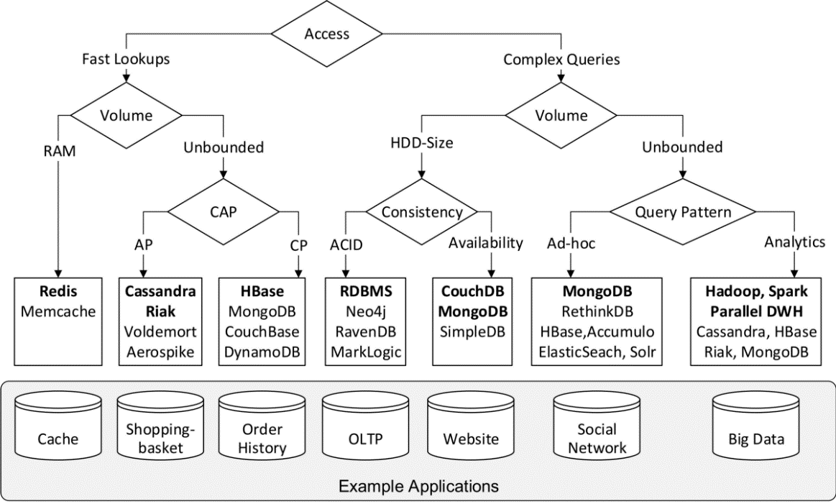

**Practice Problem 4:**

**What is Big Data?**

* This is an extremely big, computational method can be used for finding patterns, trends, and associations related to human behavior and interactions.

**How Big Data can be used to support an organization?**

* It can be used to digitalize any type of data and use this information for important business decisions which can enhance company revenue or alert companies of upcoming trends or security risks which in the end will save companies money.
* It can be used at real time and can be applied at various mediums such as
  + Top Searches engines for the month
  + Most bought items in stores

